Part 1: Azure resources
- Created a resource group called rg-healthsphere in Australia East. Every other resource goes inside it, so they share a region and are easy to manage and delete together.
- Created an Azure SQL server and database. The server uses SQL authentication with an admin login healthsphere_admin. The database is AZSQL_AUSTRALIAN_HEALTHSPHERE on the serverless tier so it pauses when idle. In networking I allowed my client IP and turned on "Allow Azure services and resources to access this server", because Data Factory needs that later.
- Created a storage account with hierarchical namespace enabled. That setting makes it ADLS Gen2, which gives real folders. Inside it I created a private container called healthsphere.
- Created an Azure Data Factory (V2, Git configuration skipped) and opened ADF Studio to confirm it worked.
- Decided not to create a Key Vault. I enter passwords directly in the linked services instead. That is fine for a learning project, and production would use Key Vault.
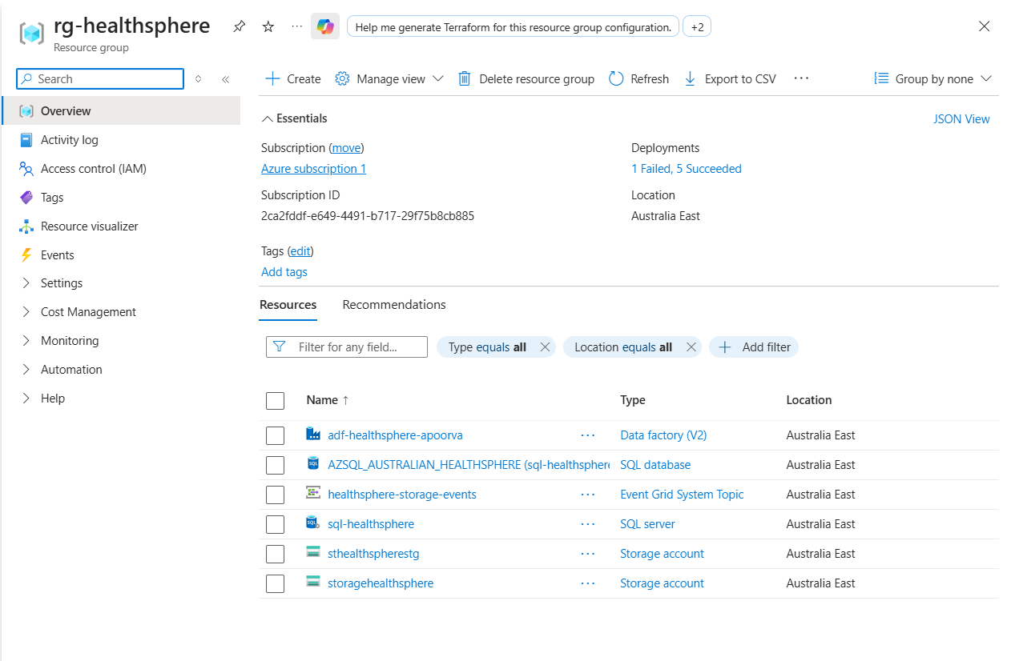

Part 2: The source database
- I built the schema in Azure SQL using the portal Query Editor.The database already existed.
- The script created four schemas (master, clinical, operations, control) and ten tables:
  - master: facility, department, bed, patient
  - clinical: encounter, diagnosis, procedure_event
  - operations: admission, patient_transfer, discharge
- I created the control table control.ingestion_config and inserted ten rows, one per source table. Each row records the schema, table, watermark column, target folder, Snowflake target table and load order. This table is what makes the pipelines metadata-driven.
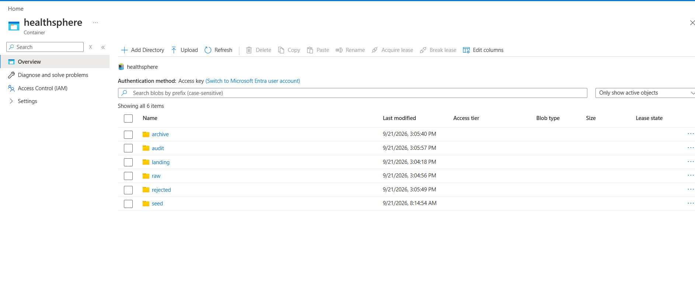

Part 3: Loading the source data
- I uploaded the ten seed CSVs to a seed folder in the healthsphere container.
- Created two ADF linked services: one to the ADLS account (account key) and one to Azure SQL (SQL authentication).
- Created two parameterized datasets: a CSV dataset that takes a file name, and a SQL table dataset that takes a schema and table name. Parameters let one dataset serve all ten tables.
- Built a one-time pipeline, PL_SEED_LOAD, with a ForEach over a fixed list of the ten tables and a Copy activity inside. Three problems came up:
  - ForEach rejected my pasted list because it needs an array, so I wrapped it in @json('...').
  - Foreign keys failed because child tables loaded before their parents, so I made the ForEach sequential and ordered the list parent-first.
  - The is_active column failed on 1/0 values, so I enabled "Treat boolean as number" in the Copy activity's type conversion.
- I cleared the partial data with DELETE statements in child-to-parent order and reran. TRUNCATE does not work here because SQL Server blocks it on tables that foreign keys point to.
- I validated the load. Row counts matched exactly: facility 8, department 56, bed 924, patient 6,000, encounter 15,000, diagnosis 22,232, procedure 8,738, admission 6,505, patient transfer 2,313, discharge 6,483.
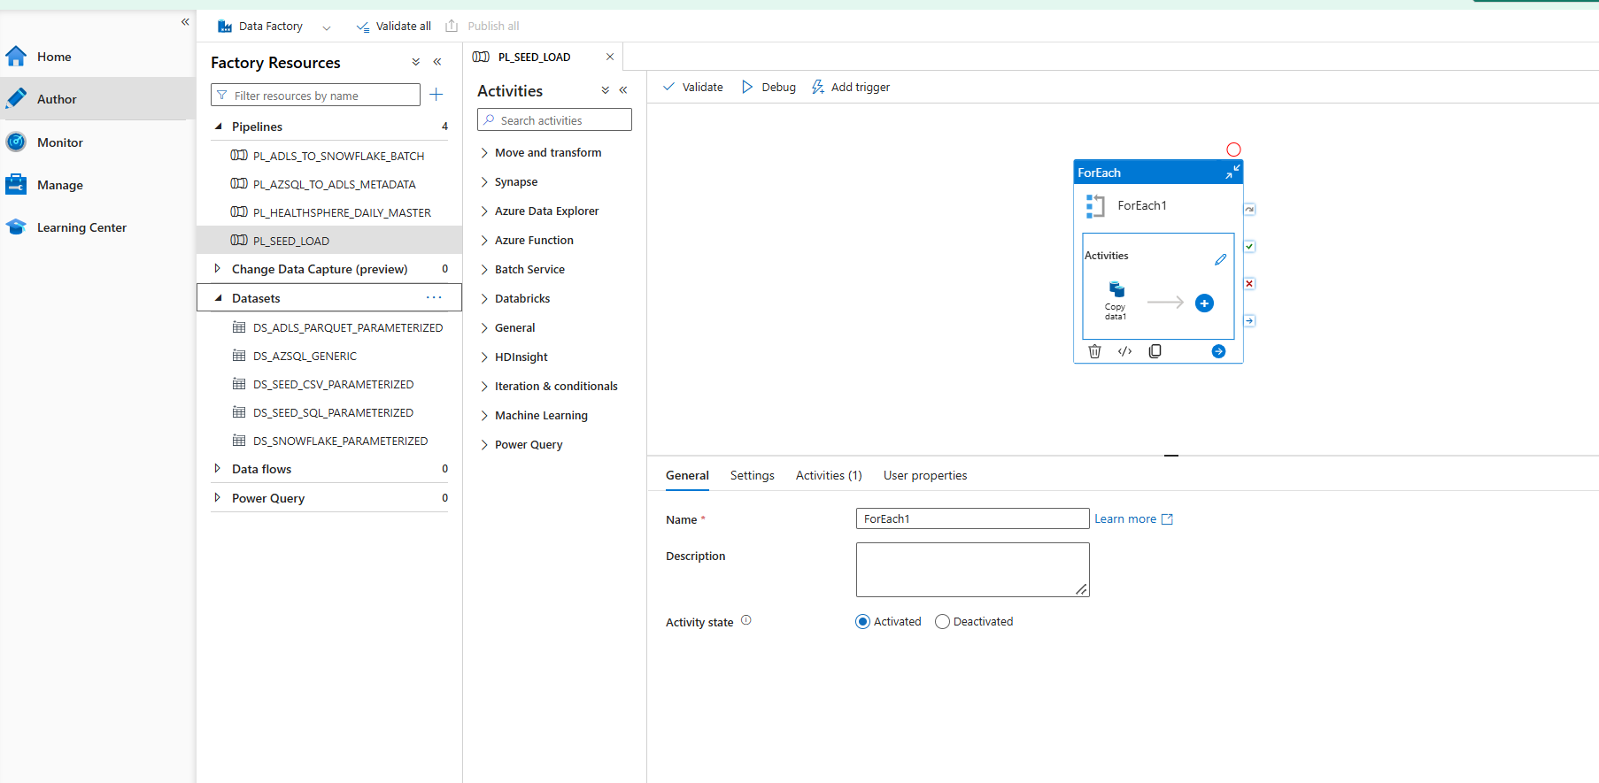

Part 4: Snowflake
- I ran the setup script in Snowsight as SYSADMIN. It created the database AUSTRALIAN_HEALTHSPHERE, the schemas RAW, STAGING, INTERMEDIATE, MART and AUDIT, two XSMALL warehouses (HEALTHSPHERE_INGEST_WH and HEALTHSPHERE_DBT_WH, both auto-suspending), three file formats (Parquet, CSV, JSON) and 13 RAW tables. Ten mirror the source tables, and three (staff roster, ward capacity, department target) are for files. Each RAW table also has lineage columns: ingestion timestamp, batch ID, source file name and ADF run ID.
- I set up key-pair authentication. I generated an RSA key pair with openssl, then ran ALTER USER ... SET RSA_PUBLIC_KEY in Snowflake as ACCOUNTADMIN. Automated tools like ADF and dbt use a key instead of a password.
- I created two roles. HEALTHSPHERE_LOADER is for ADF and gets read/write on RAW. HEALTHSPHERE_TRANSFORMER is for dbt and gets read on RAW plus full control of the downstream schemas. I granted both to my user.
- I created the Snowflake linked service in ADF (LS_SNOWFLAKE_V2) with key-pair authentication, the loader role, the ingest warehouse and the RAW schema, and tested it successfully.

Part 5: The ADF pipelines
- I created the ADLS folder structure inside the container: landing/, raw/azuresql/, raw/files/, archive/, rejected/ and audit/. The extract pipeline writes into raw/azuresql/ and Snowpipe watches raw/files/. The other folders are created but not used yet.
- I built PL_AZSQL_TO_ADLS_METADATA (extract). A Lookup reads the active rows from the control table, and a sequential ForEach runs a Copy activity per table. Each Copy runs a query filtered by the watermark column and a window-end parameter, and writes a Parquet file to raw/azuresql/<schema>/<table>/load_date=<date>/. One error taught me that a long expression pasted with a line break gets a leading space, and ADF then treats it as plain text. I re-entered it as one line.
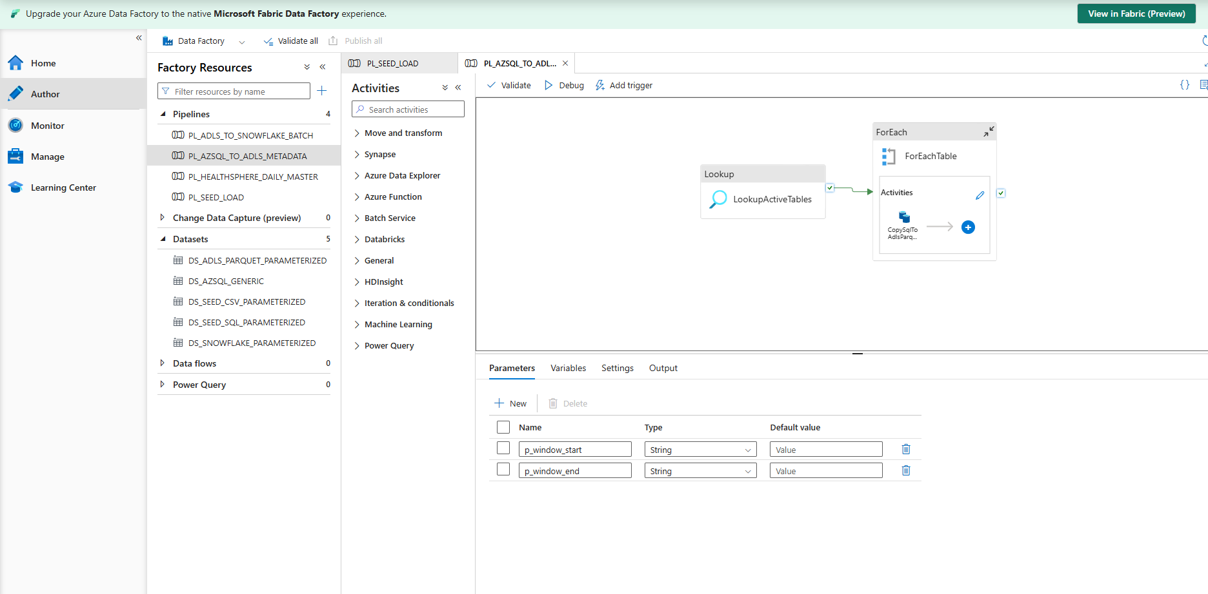
- I built PL_ADLS_TO_SNOWFLAKE_BATCH (load). It has the same Lookup and ForEach, and each Copy reads the Parquet file and loads it into the matching RAW table. The supplied template loaded one file at a time and had no loop, so I gave this pipeline its own loop. I hit a chain of Snowflake sink problems:
  - Direct copy from ADLS Gen2 is not supported, so I enabled staging.
  - Staging rejected the ADLS Gen2 account, so I created a separate plain Blob storage account and a linked service with SAS URI authentication.
  - The staged copy needed permission to create a temporary stage, so I granted CREATE STAGE on the RAW schema to the loader role.
  - The Parquet files had 9 columns and the RAW tables had 13 (the extra lineage columns), so I set the sink format option ERROR_ON_COLUMN_COUNT_MISMATCH = false.
- 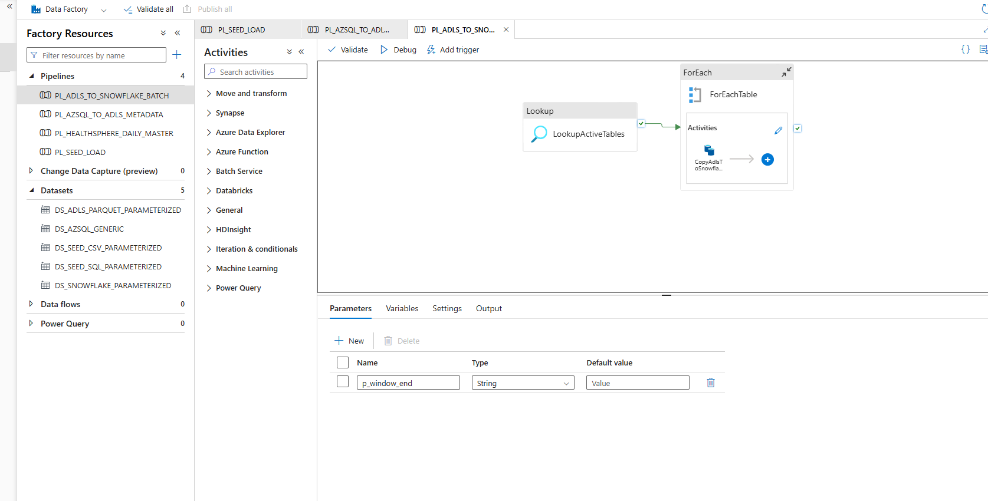
- I built PL_HEALTHSPHERE_DAILY_MASTER. It runs the extract pipeline, then the load pipeline only if the first succeeded.
- I tested the whole chain. I truncated the Snowflake RAW tables so my earlier test runs would not cause duplicates, ran the master pipeline, and confirmed the RAW row counts matched Azure SQL.
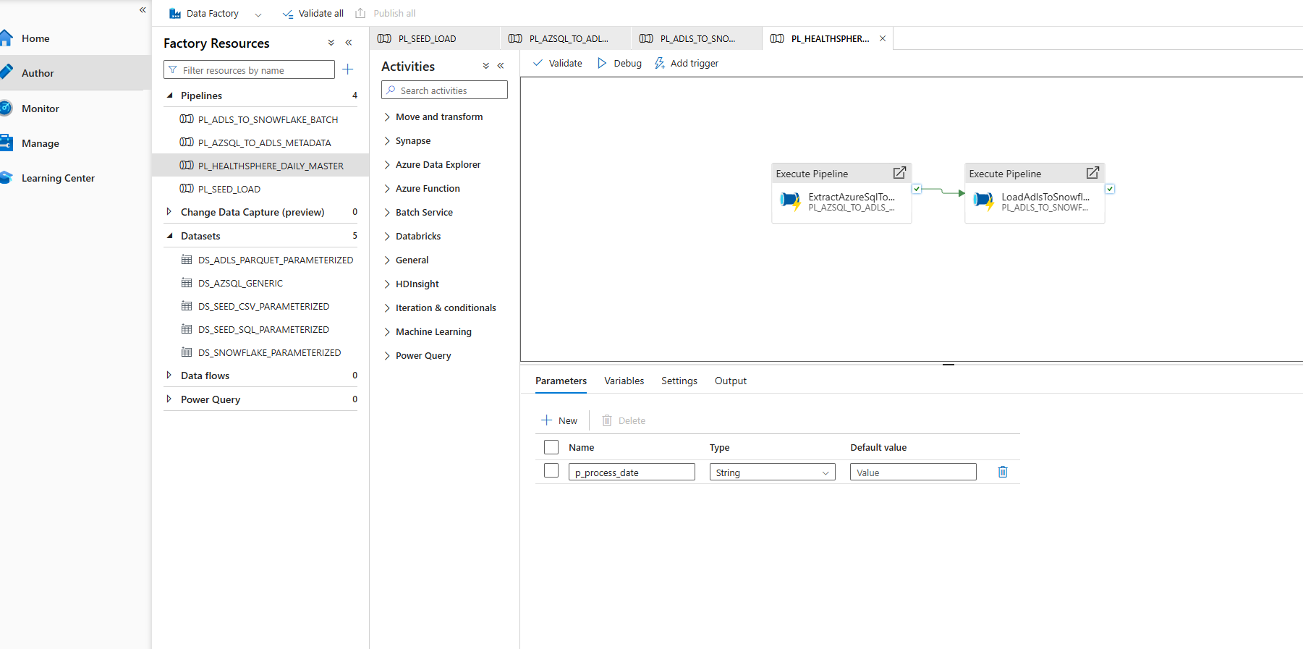

Part 6: Loading the file-based data
- I uploaded three files into raw/files/: a staff roster CSV, a ward capacity CSV and a department targets JSON.
- I created a Snowflake storage integration and an external stage pointing at the raw path of the container. I opened the integration's consent URL and gave Snowflake's service principal the Storage Blob Data Contributor role on the storage account. LIST on the stage then showed my files.
- I loaded the files with COPY INTO. Counts matched: 84,051 staff roster rows, 5,096 ward capacity rows and 280 department target rows.

Part 7: dbt
- I installed dbt with pip install dbt-snowflake in Anaconda Prompt. I chose local dbt Core over Snowflake's built-in dbt option because it matches the project files exactly.
- I created profiles.yml in my .dbt folder with the account, user, key path, transformer role, HEALTHSPHERE_DBT_WH and database, and dbt debug passed all checks.
- I ran dbt build and got 38 of 38 passing with no errors. The layers are:
  - Staging views clean each RAW table and keep the latest record per key.
  - Intermediate models hold the business logic: length of stay, delayed discharge, 28-day readmission and daily occupancy. They are ephemeral, so they run inside downstream queries and do not appear as objects in Snowflake.
  - Marts are the star schema: five dimensions (patient, facility, department, bed, date) and four facts (admission, encounter, bed occupancy daily, staffing daily). Facts use incremental merge.
  - Tests cover uniqueness, not-null, relationships, accepted values and a check that no discharge happens before admission.
- I checked the MART tables. Dimensions and the admission and encounter facts matched their source counts. Bed occupancy has 5,096 rows and staffing has 15,288 daily aggregate rows.

Part 8: Power BI
- I connected Power BI Desktop to Snowflake with the HEALTHSPHERE_TRANSFORMER role in import mode and loaded the nine MART tables.
- I built the star schema relationships, 15 in all. Each fact connects to its dimensions through hashed key columns, and dates join through an integer date key.
- I renamed the tables to readable names like Fact Admission and Dim Department, and created a dedicated _Measures table to hold all DAX measures in one place.
- I wrote about 28 DAX measures, including patient and admission counts, occupancy percent, average length of stay, 28-day readmission rate, delayed discharge hours, average wait, staff hours and absence rate, and percent seen within triage target. I formatted the percentage ones.
- I imported four more staging tables because the mart layer had nothing for them: department targets, patient transfers, diagnoses and procedures. I related each to the model (targets to Dim Department, transfers to Fact Admission, diagnoses and procedures to Fact Encounter).
- I built an actual-versus-target matrix. A SWITCH measure picks the right actual value for each metric code (occupancy, length of stay, wait, readmission, staffing ratio) so it can sit next to the target. It shows blank until the rows are expanded to the metric level, because one metric must be in context.
- I built three dashboards:
  - Executive Overview: five KPI cards, the actual-vs-target matrix, a trend line, a facility occupancy bar chart, admissions by type, admissions by state and a sorted department table. Map visuals were blocked on my machine, so I used a state bar chart.
  - Bed Occupancy and Flow: occupied and available bed cards, a daily occupancy trend with a target line, a facility-by-department heat map with conditional colouring, length of stay by department, delayed discharge hours by facility, an admissions/transfers/discharges chart and a patient detail table with a drillthrough page.
  - Department and Patient Performance: KPI cards, wait time by triage category, readmission rate by department, diagnosis and procedure mix, staff hours against admissions, and the target matrix again.

Part 9: Row-level security and bookmarks
- I imported the user access list as Security User Access and defined three roles. Executive has no filter and sees everything. FacilityManager filters Dim Facility by the signed-in user's email. DepartmentManager filters Dim Department the same way.
- I tested with "View as", ticking the role and typing a test user's email. The first result was wrong: the targets matrix still showed all facilities. Adding a relationship between department and facility would have created ambiguous paths, so I added a second filter on Dim Department inside the FacilityManager role instead. After that, a facility manager saw only their hospital, and a department manager saw only one department.
- I created six bookmarks (Show KPI Definitions, Hide KPI Definitions, Executive View, Occupancy View, Department View, Reset Filters). The KPI ones toggle a definitions overlay using the selection pane. I added a bookmark navigator and grouped the four navigation bookmarks so only those show.

Part 10: Snowpipe automation
- I registered the Microsoft.EventGrid resource provider on the subscription after the first attempt failed with a "not registered" error.
- I created a storage queue named healthsphere-file-events and an Event Grid subscription on the storage account. It fires on Blob Created events under raw/files/ and delivers them to the queue.
- I created a Snowflake notification integration pointing at the queue, opened its consent URL and gave Snowflake's service principal the Storage Queue Data Contributor role.
- I created three pipes with auto-ingest on: one each for staff roster, ward capacity and department target, reading from the external stage.
- I ran the live test. I uploaded a new staff roster file to raw/files/workforce/ without touching ADF or running any SQL. Snowflake loaded all 84,051 rows on its own, and COPY_HISTORY showed the load under the pipe name.

Part 11: Final validation
- I checked every item on the validation list: source counts, the control table returning ten rows, Parquet files in ADLS, COPY_HISTORY, RAW reconciliation, the clean dbt build, key uniqueness, Power BI totals against Snowflake, RLS behaviour, bookmarks and the Snowpipe auto-load. All passed.

